POWER BI ASSIGNMENT2-DAX&DATA VISUALIZATION
Fathima Sabeeha T
Calculated Columns:
- ● Create a Calculated Column for 'Category Type': Add a calculated column in theOrder Details table that combines the 'Category' and 'Sub-Category' columns into a single 'Category Type' column● Calculate Revenue per Order in Order Details Table: Create a calculated column in
- the Order Details table to compute the revenue (Amount * Quantity) per order.
- Create a Calculated Column to Categorize Sales: Add a calculated column named‘Sales Category’ in the Order Details table that categorizes each order as 'AboveAverage' or 'Below Average' based on the Amount value
- 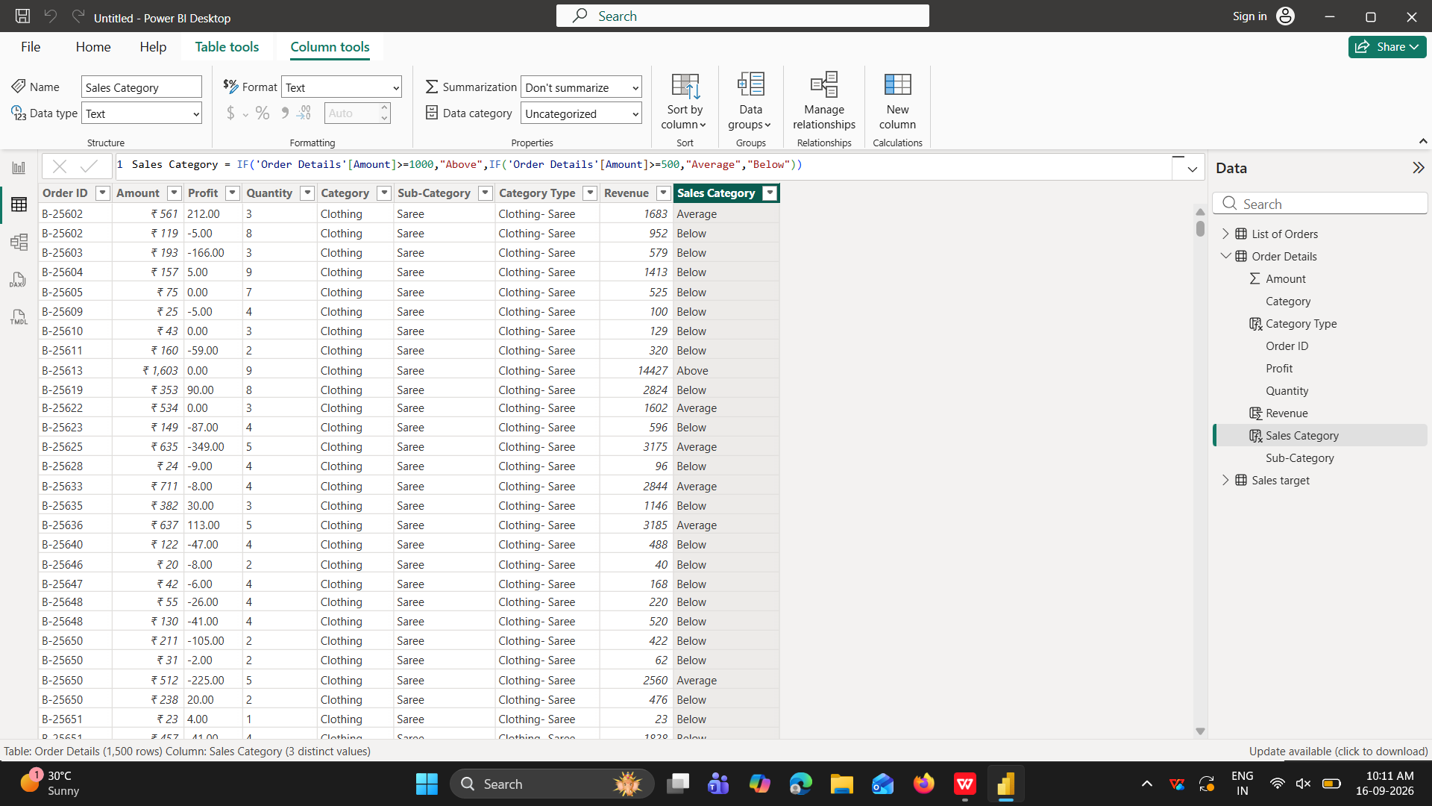

Calculated Measures:
● Calculate Order Count: Define a measure to count the total number of orders in theOrder Details table
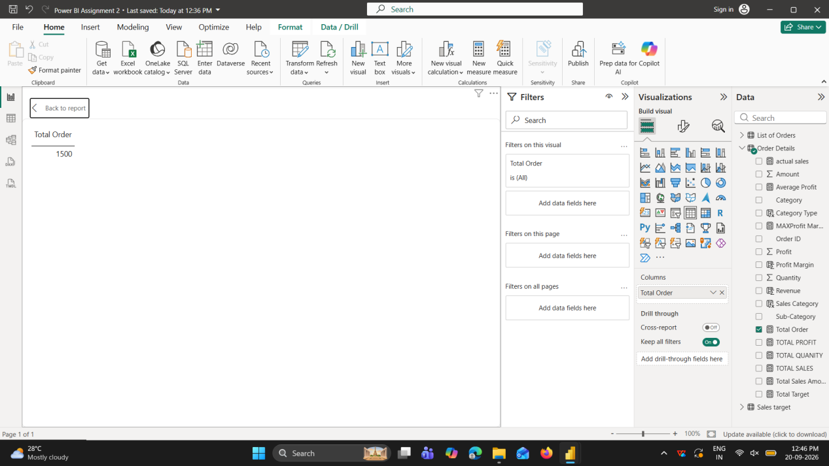
● Calculate Average Profit in Delhi: Create a measure to calculate the average profit for
orders placed in Delhi.
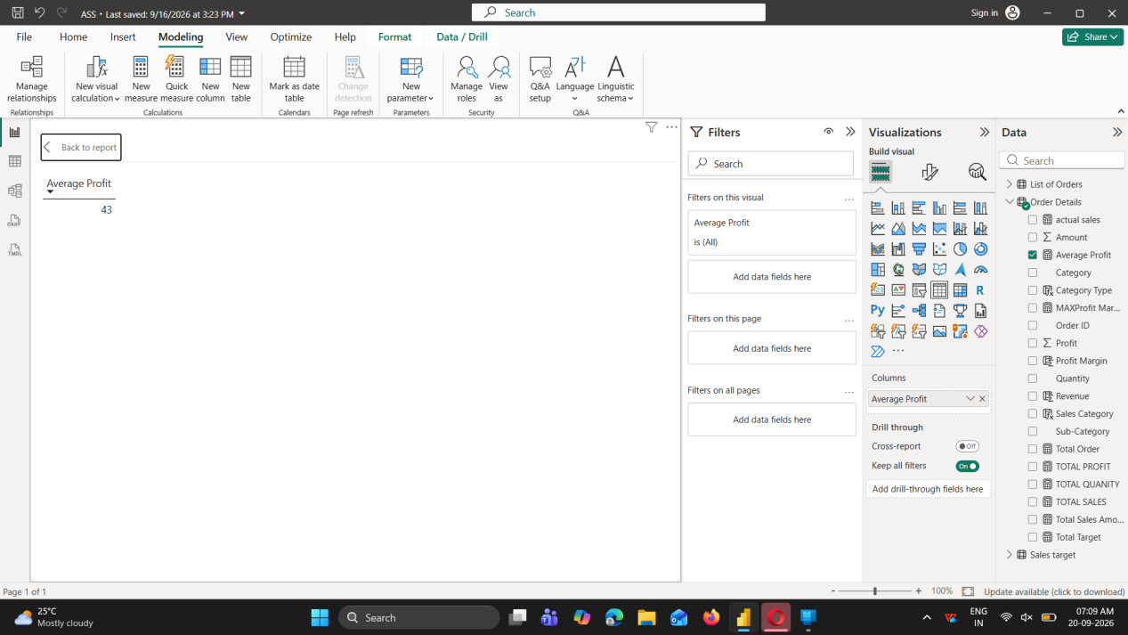
.Calculate Year-to-Date (YTD) Sales: Define a measure to calculate the total sales
amount accumulated from the earliest order date up to each order date.
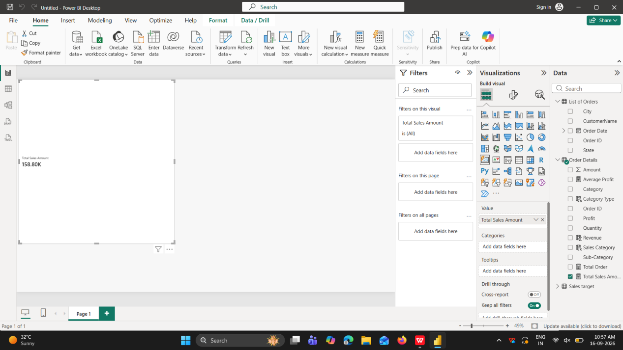

Data Visualization:
Sales Target Achievement by Category: Compare actual sales with sales targets by category using a clustered column chart.
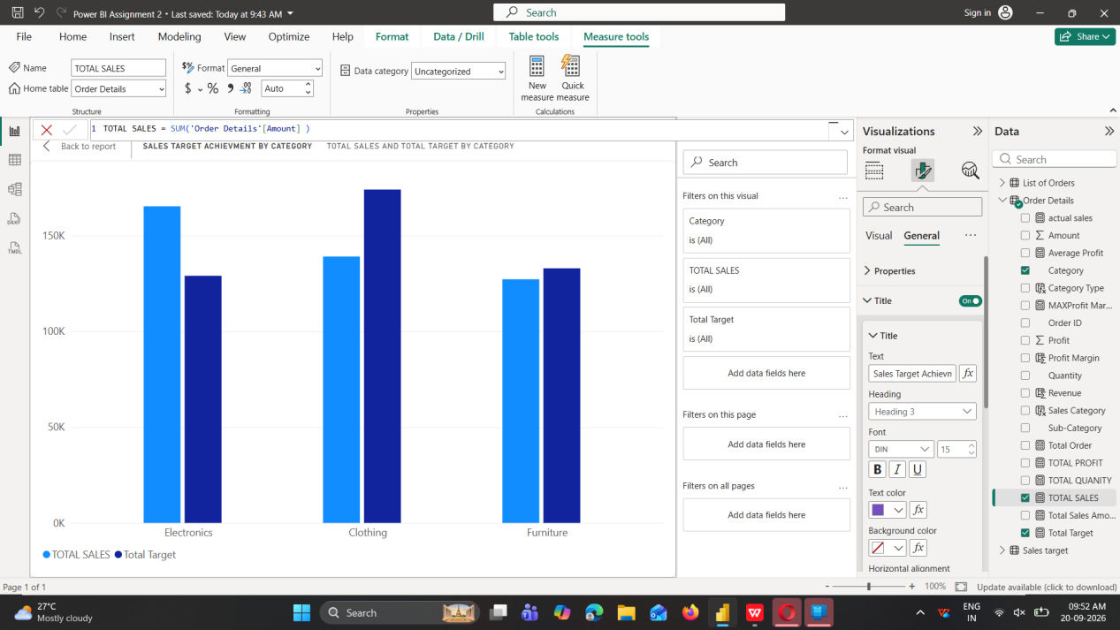

Max Profit Margin by Sub-Category: Analyze the maximum profit margin for each sub-category of products using a donut chart
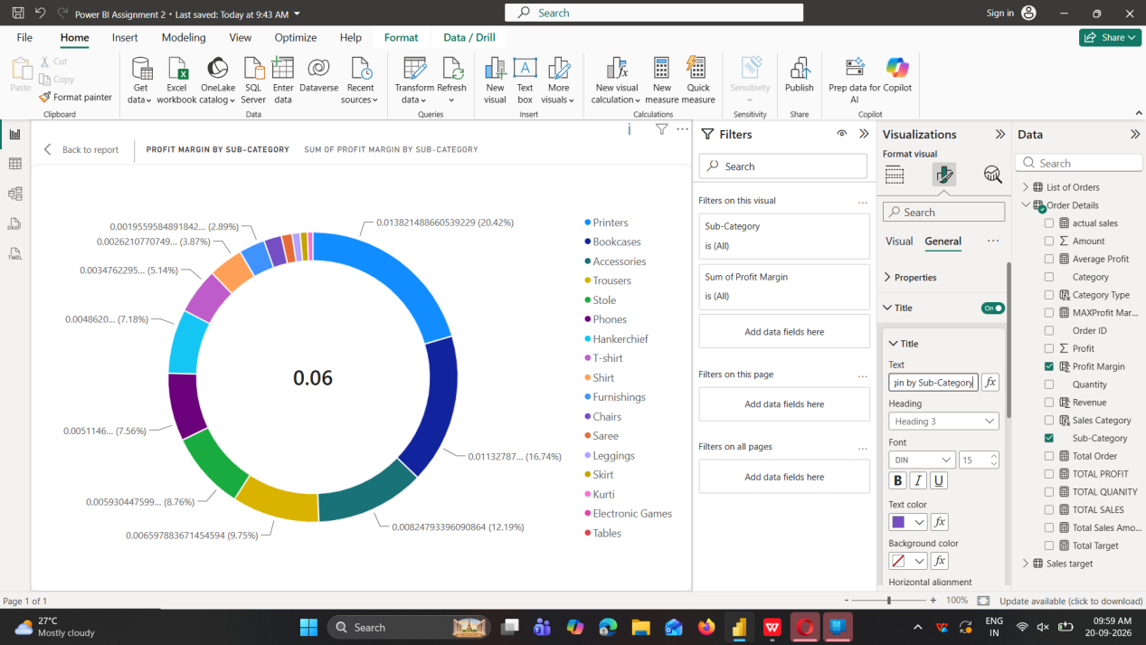

Monthly Sales Trend: Show the trend of monthly sales over time using a line chart.
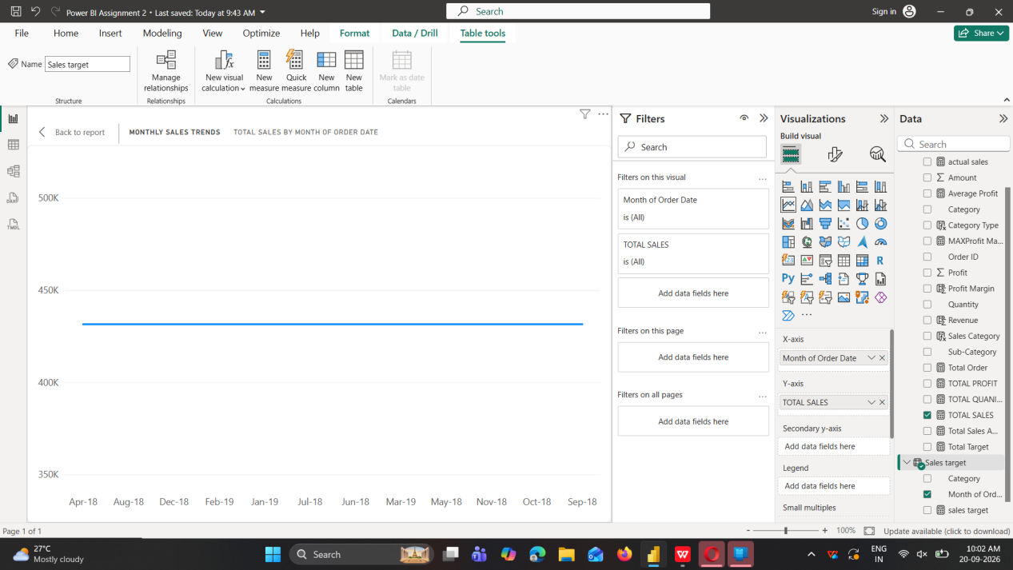
Comparison of Profit and Quantity by Sub-Category: Compare the relationship between
profit and quantity sold for different sub-categories using a scatter chart.
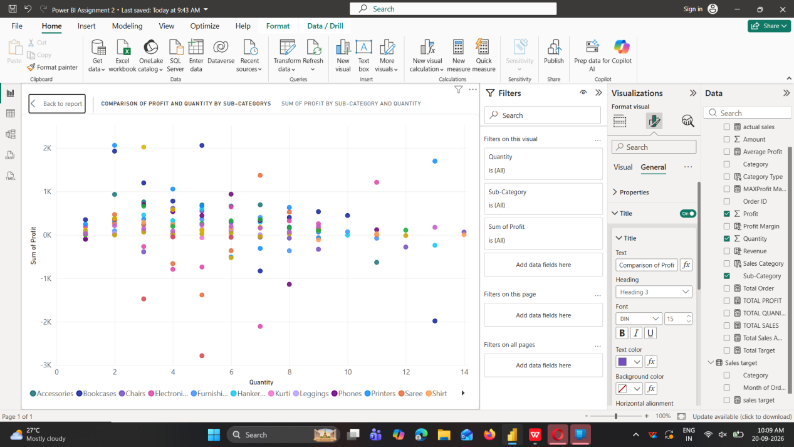

Comparison of Total Sales Amount and Target: Create cards to succinctly display the total
sales amount alongside the sales target for quick comparison and analysis. Also, create a
multi-row card to d
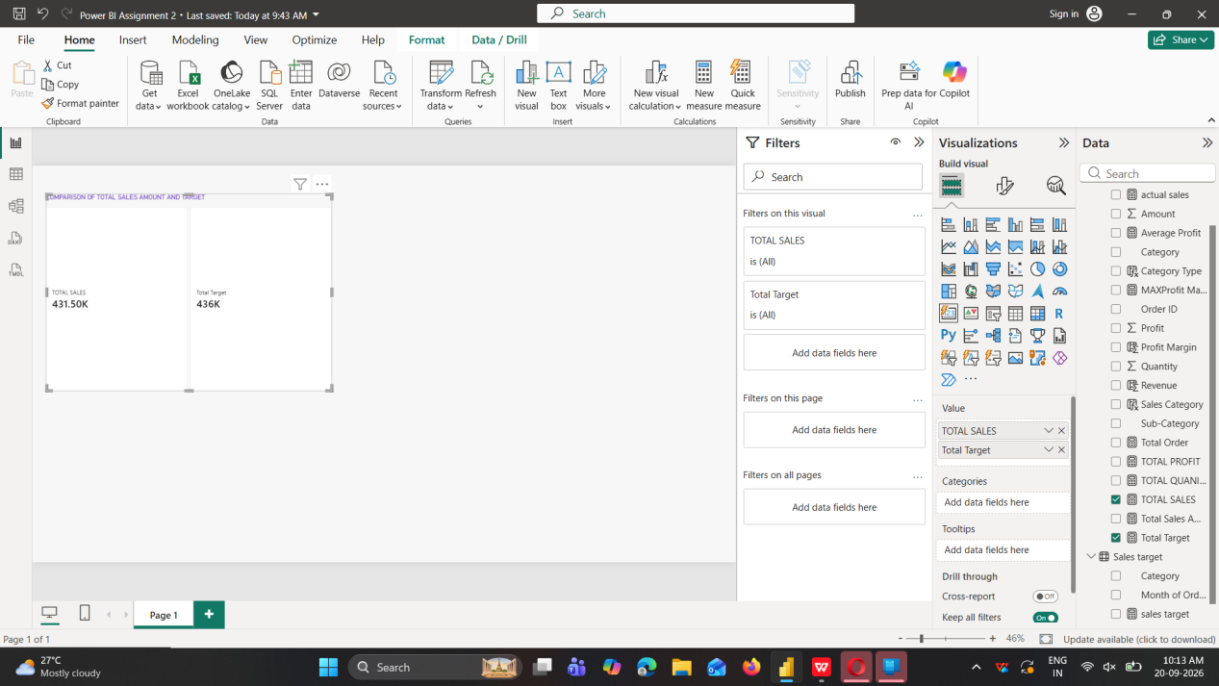
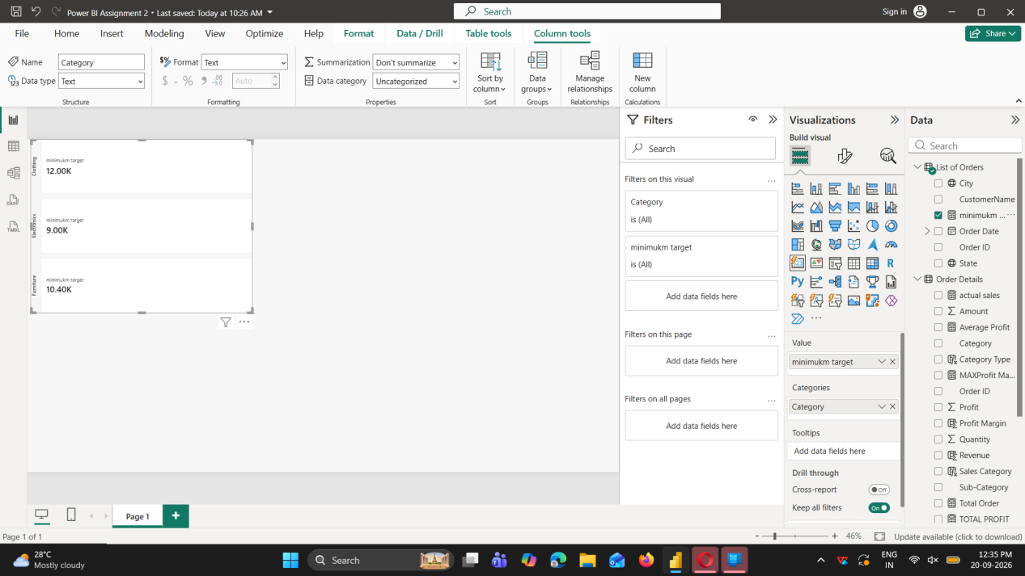

Sales Performance Matrix: Build a matrix view to analyze how actual sales compare to sales targets across different categories and months.
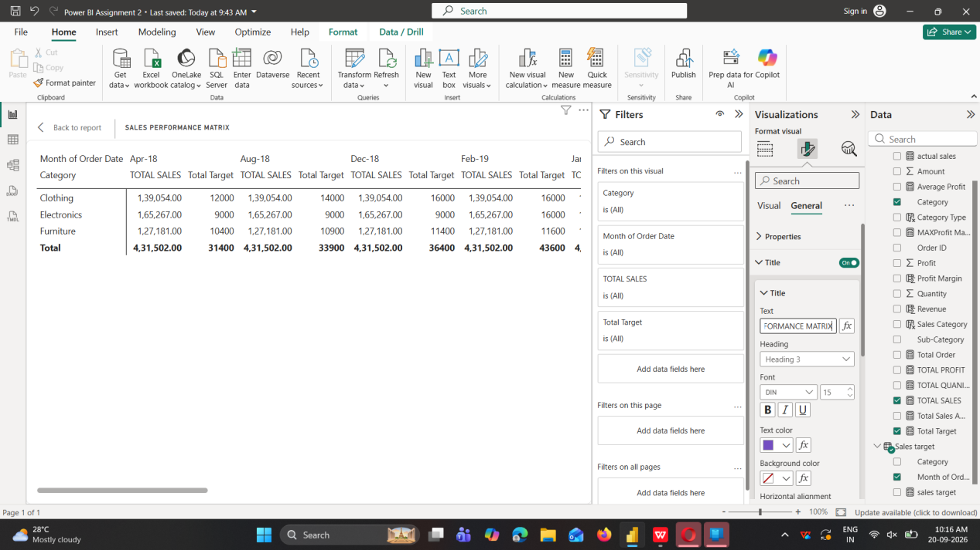
Geographic Sales Analysis: Visualize total sales on a map by city to identify regional sales
patterns.
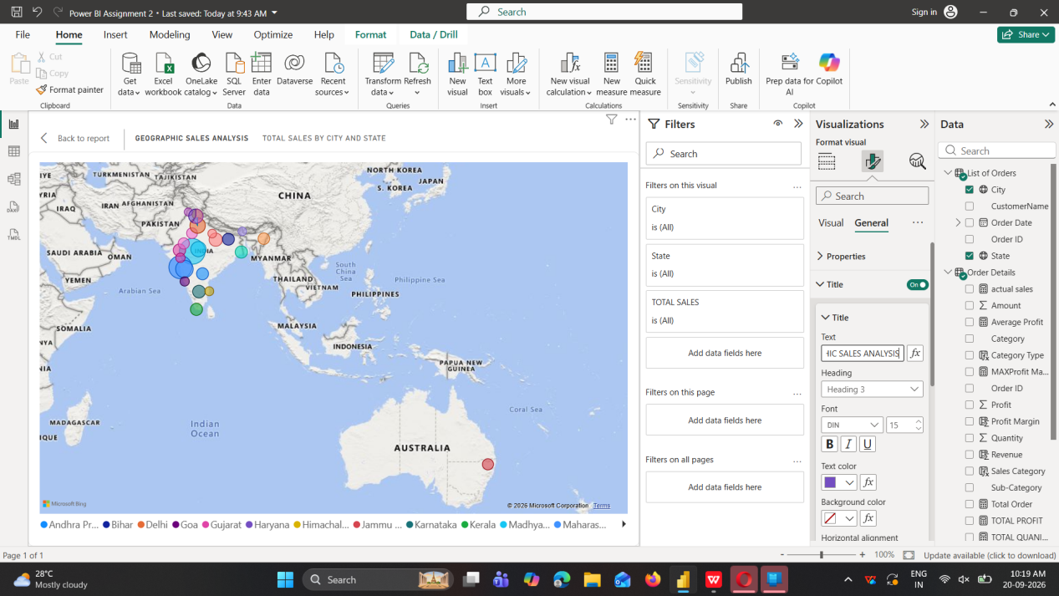
Sales Distribution by Sub-Category: Represent the sales distribution across different
sub-categories using a treemap.
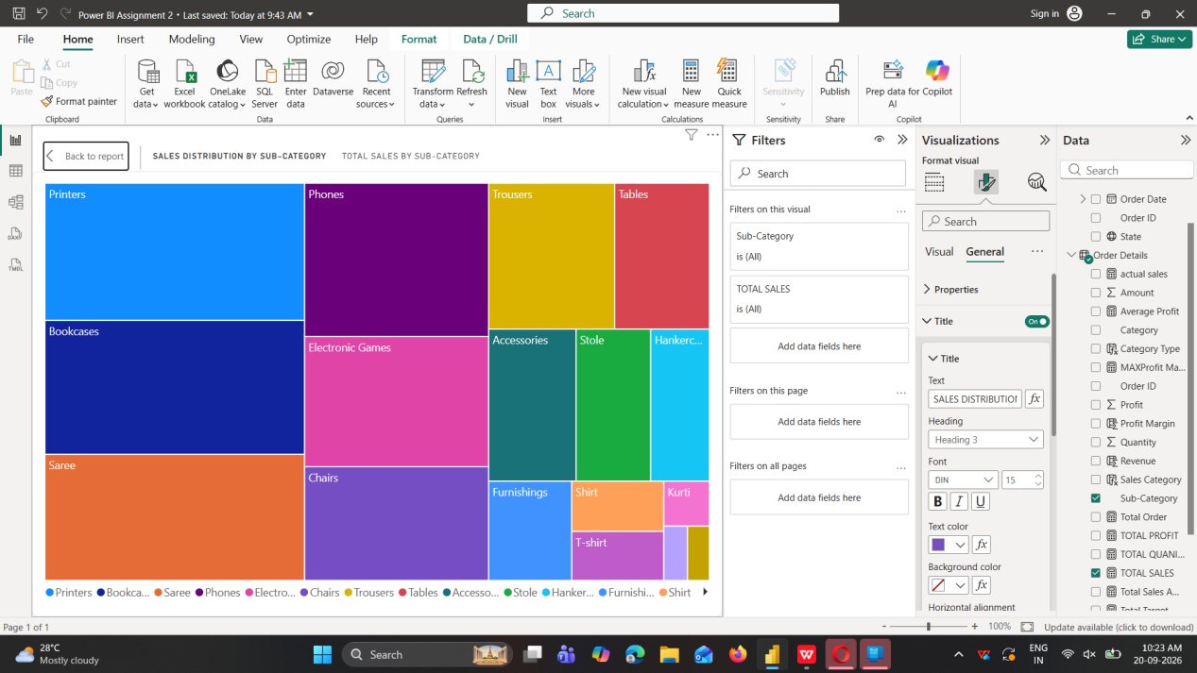
Order Count Analysis by State: Create a funnel chart to visualize the distribution of order
counts across different states.
